**Practical – 4 Delegates and events**

Q-1. Create a delegate Cal Area(float a, float b) with two float type parameters and having void return type. Create delegate instances for Calculate area of rectangle and triangle and display result on the screen.

**Code:-**

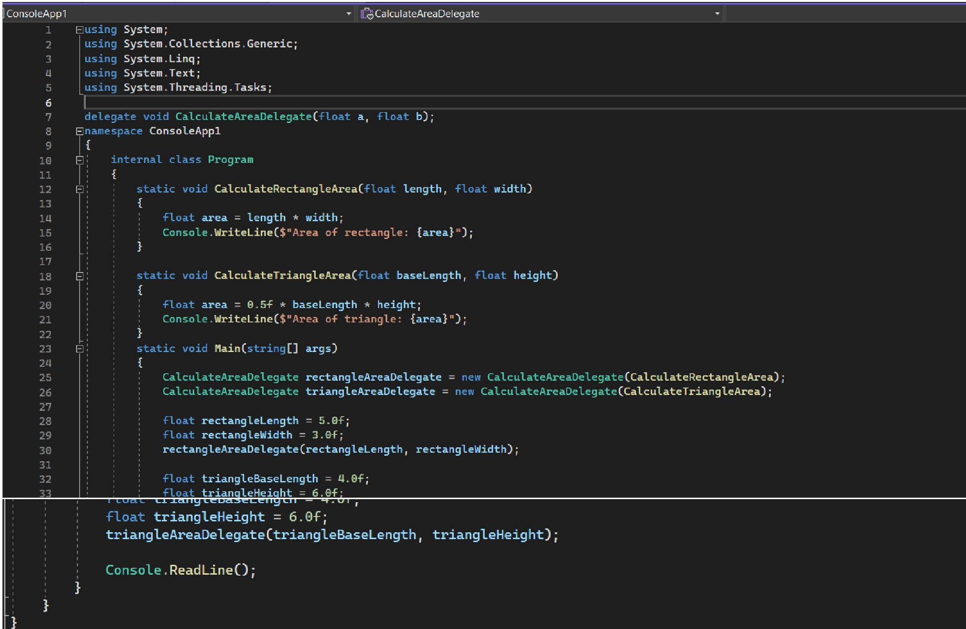

**Output:-**

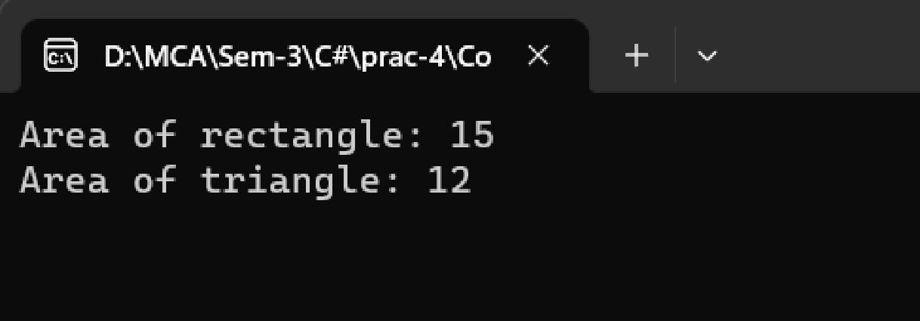

**Practical – 4 Delegates and events**

Q-2. Create a delegate with one string parameter and having string return type. Use delegate firstly for concateStr() and secondly use it for reverseStr()method. Create instances of delegate and display concat as well as reverse string by combining delegate instances.

**Code:-**

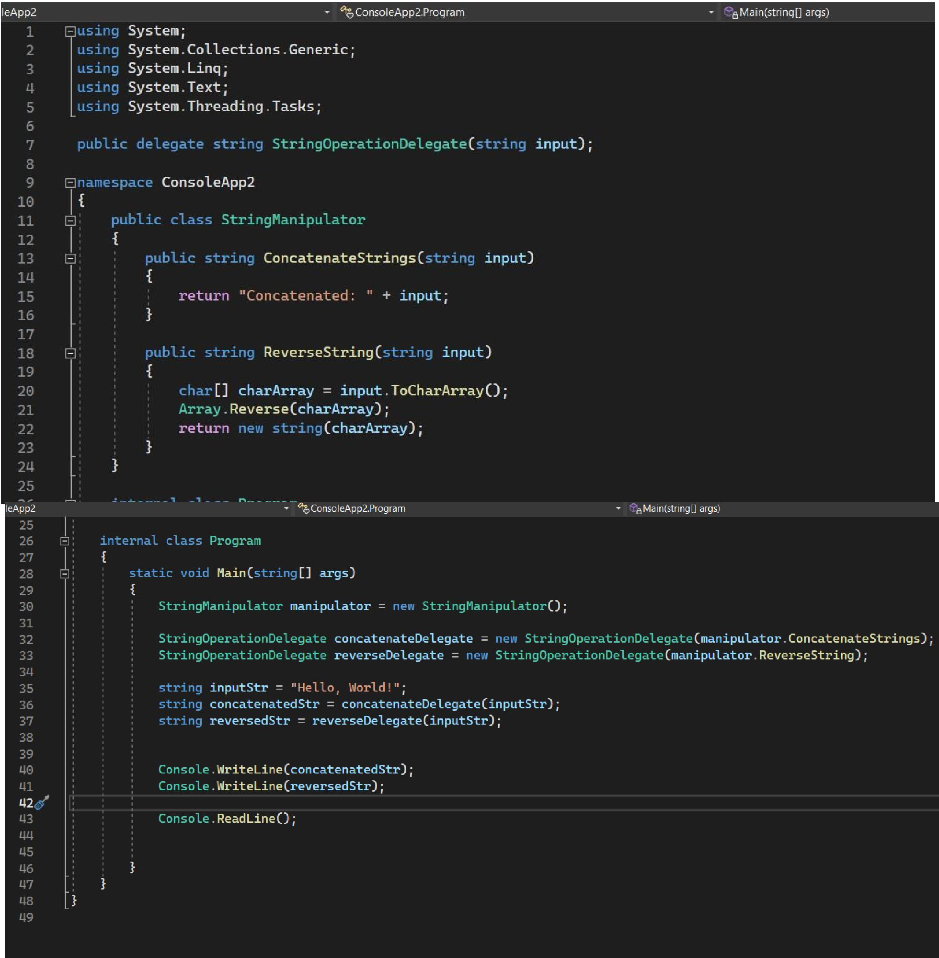

**Practical – 4 Delegates and events**

**Output:-**

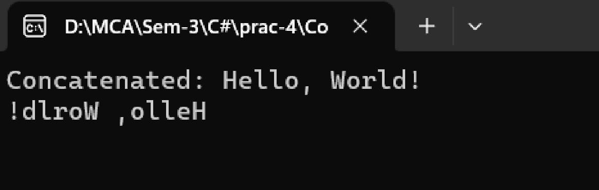

3. Create a program which implements delegate with event model for string modification. Whenever string is modified (by Replace()) fire an event to display a message that is “String is modified”.

**Code:-**

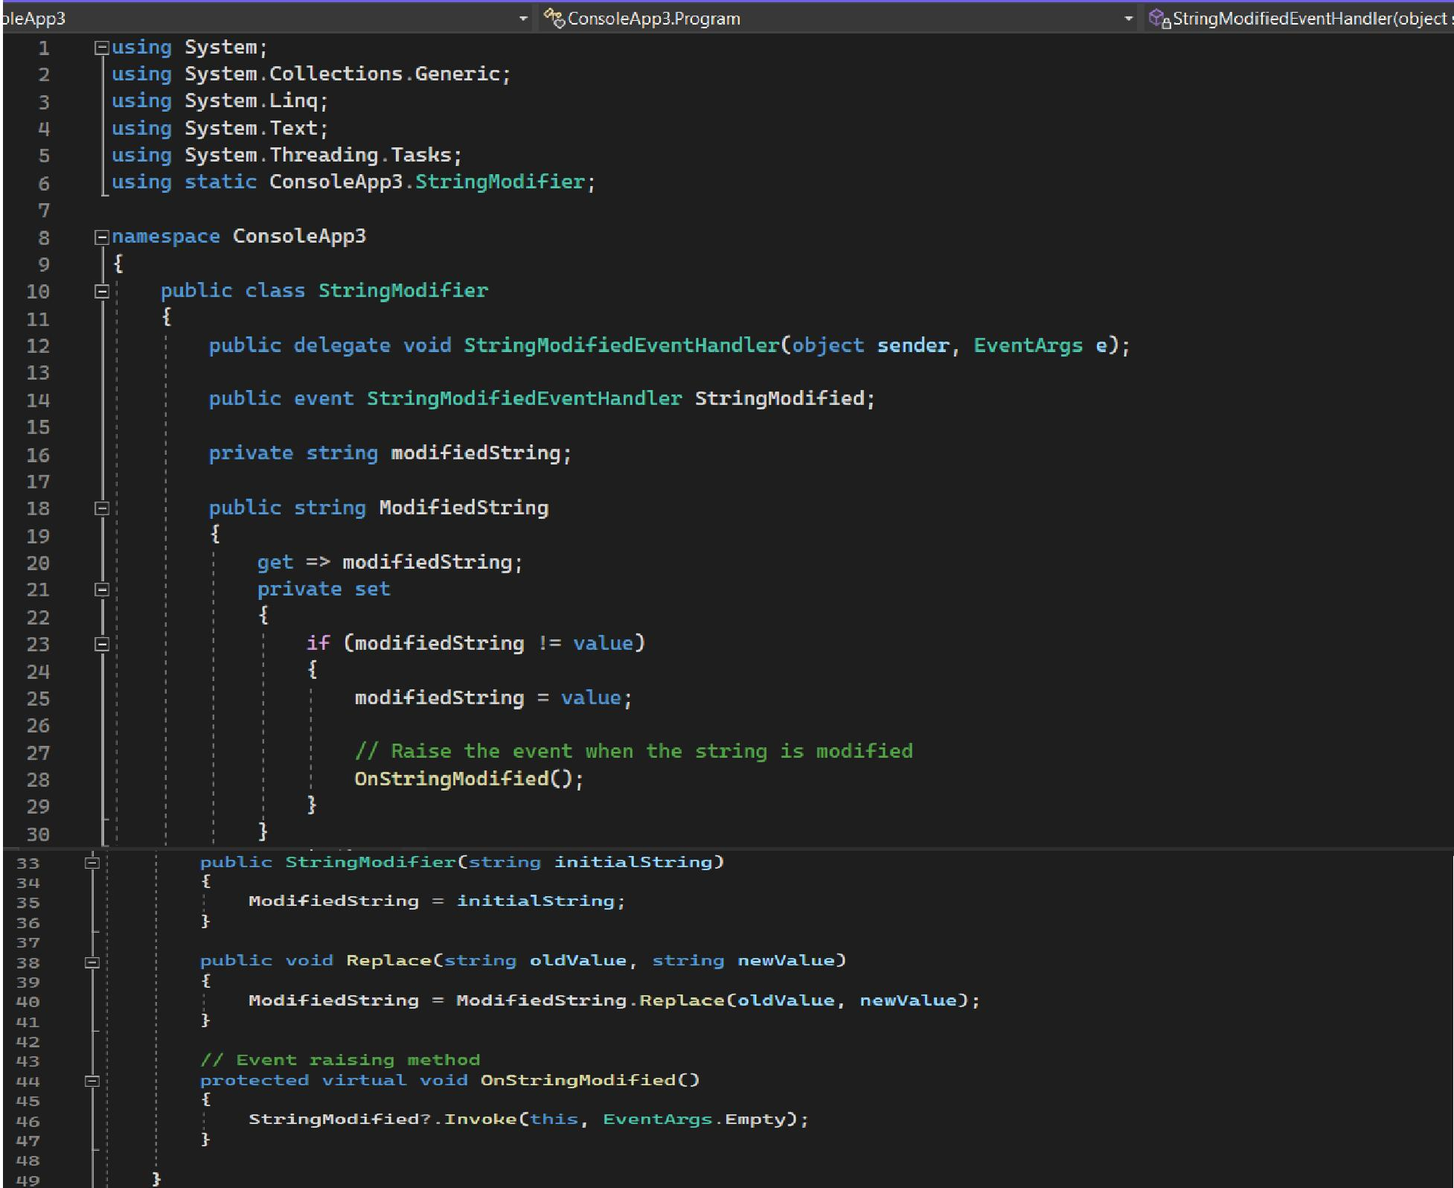

**Practical – 4 Delegates and events**

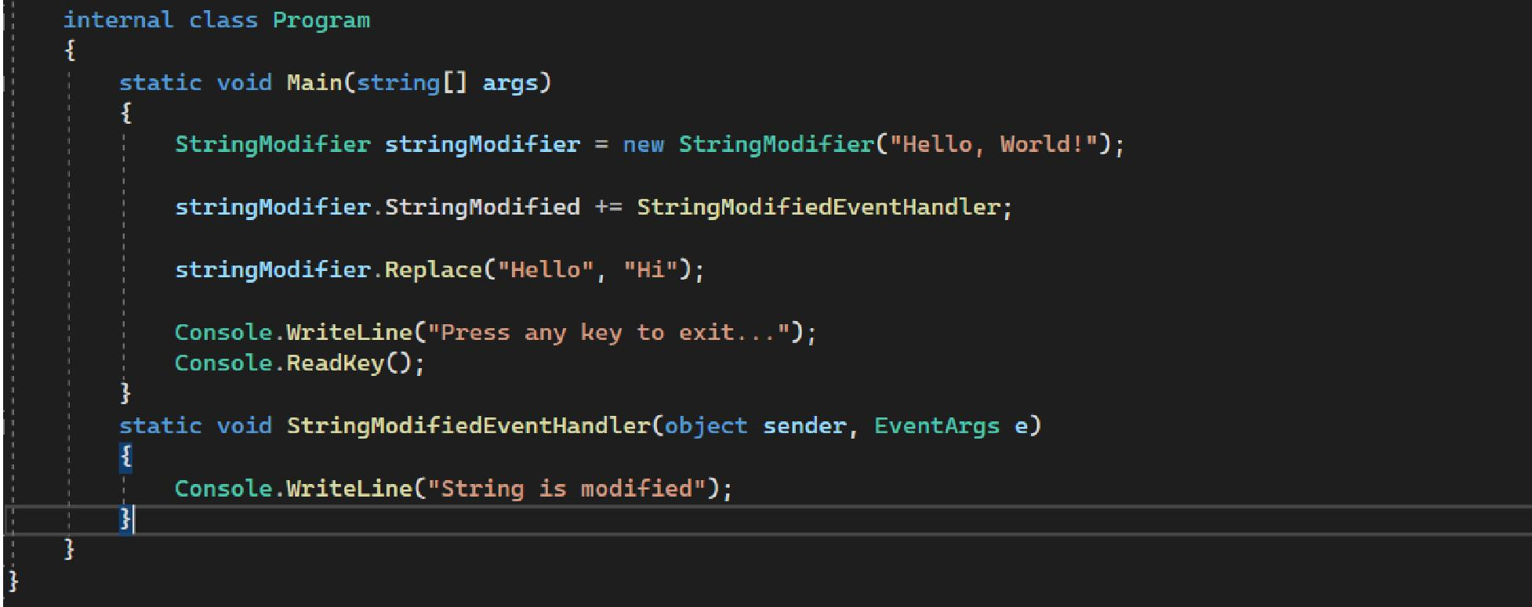

**Output:-**

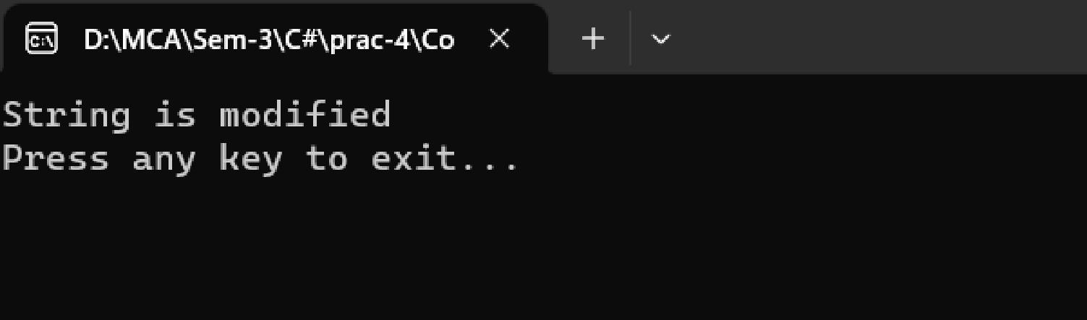

4. Write a program to create a delegate called TrafficDel and a class called TrafficSignal with the following delegate methods.

Public static void Yellow() {

Console.WriteLine(“Yellow Light Signal To Get Ready”); }

Public static void Green() {

Console.WriteLine(“Green Light Signal To Go”); }

Public static void Red() {

Console.WriteLine(“Red Light Signal To Stop”);

}

**Practical – 4 Delegates and events**

Also include a method IdentifySignal() to initialize an array of delegate with the above methods and a method show() to invoke members of the above array.

**Code:-**

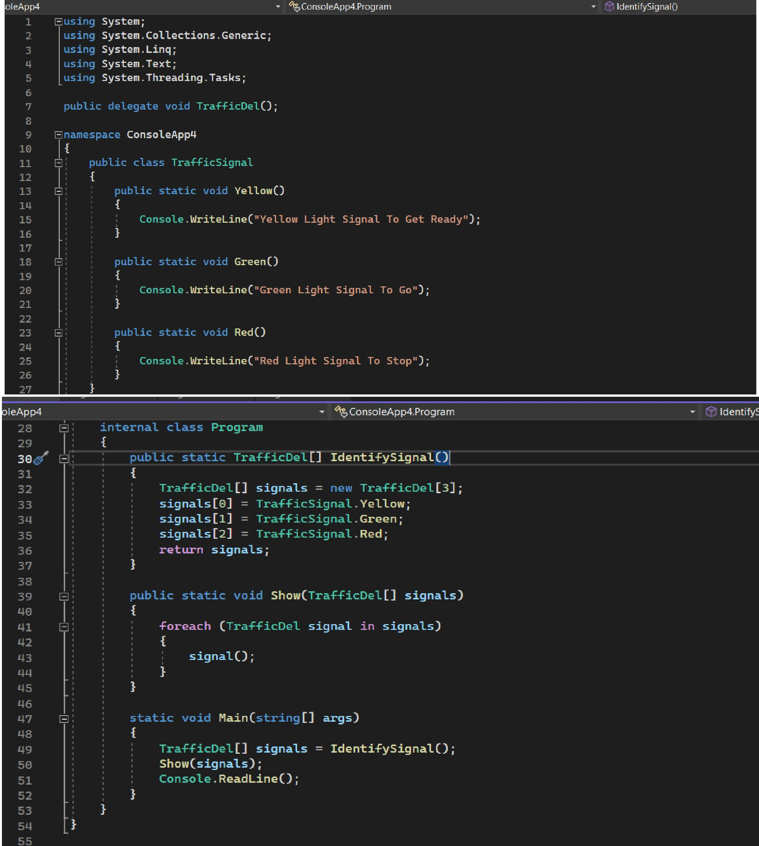

**Practical – 4 Delegates and events**

**Output:-**

